Chapter 5, Problem 28

Find i_{o} in the op amp circuit of Fig. 5.66.
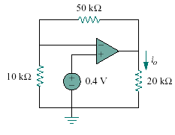

Figure 5.66
For Prob. 5.28.

